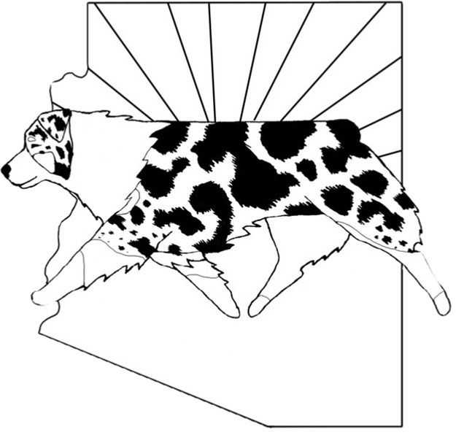
Australian Shepherd Club of Arizona

Working Judge’s Contract

The following is an agreement between the Australian Shepherd Club of Arizona (ASC of AZ) and _______________________________________ (Judge) for the dates of _______________________.

- The Judge agrees to judge up to 40 runs of stock per day (ducks and/or sheep/goats and/or cattle) during the dates of hire.

- The ASC of AZ agrees to pay the Judge $ __________ per day judging fee.

- Expenses are reimbursed as follows:

  - The ASC of AZ also agrees to pay for travel expenses (round trip airfare or mileage). Mileage is reimbursed at the current IRS mileage rate or the cost of roundtrip airfare (whichever is less).
  - Parking/transportation costs pertaining to the above travel. It is understood that airport related parking may have to be estimated.
  - The ASC of AZ agrees to provide lodging and meals. With receipts, meals not provided by the ASC of AZ will be reimbursed up to $7.00 for breakfast, $10.00 for lunch and $15.00 for dinner.
  - NO OTHER FEES WILL BE PAID AND NO ADDITIONAL EXPENSES WILL BE REIMBURSED WITHOUT PRIOR APPROVAL BY AN ASC OF AZ CLUB MEMBER AUTHORIZED TO APPROVE SUCH CLUB EXPENDITURES.

Please indicate airport that you fly in and out of: __________________________________________.
Best time to fly out: _________________________________________________________________.
Best time for return flight: ____________________________________________________________.

If air fare ticket prices are not a factor, do you have any airline preference? List in order of preference with your frequent flyer number.
Airline ______________________________________#__________________________
Airline ______________________________________#__________________________

Allergies: __________________________________________________________________________.
Beverage choice: ___________________, _______________________ & ______________________.
Any food requirements, i.e., vegetarian, diabetic, etc? ______________________________________.

Emergency contact phone number and relationship: _______________________________________.

Australian Shepherd Club of Arizona

Working Judge’s Contract

Page Two

It is mutually understood and agreed that no alteration or variation of the terms of this Contract shall be valid unless made in writing and signed by the parties involved and that no oral understanding or agreements incorporated herein, and no alteration or variations of the terms hereof unless made in writing between the parties shall be binding on any of the parties.

I agree to the terms of this contract.

Judge’s Signature: _____________________________________ Date: ___________________________

Home Phone: ________________ Cell Phone: _______________Email: ___________________________

ASC of AZ Contacts for your reference:

Course Director: ______________________________________ Cell: ____________________________

Course Director: ______________________________________ Cell: ____________________________

Other: ______________________________________________ Cell: ____________________________

Please keep one copy of this contract for your records and return a signed copy
in the enclosed envelope. Thank you.

Rev. Dec. 2008

